PROJECT REPORT
OF
CO-OP Project at Industry (Module-2)
ON
AI-Powered Credit Scoring and Document OCR System for Loan Risk Assessment
Submitted in partial fulfilment of the requirements for the award of degree of
BACHELOR OF ENGINEERING
In Computer Science and Engineering

Submitted by
Om Tomar (2210994882)
Sahajpal Singh (2210994831)
Ridhima Chopra (2210994826)
Ishpreet Kaur (2210990424)

Supervised By: Lalit Sharma
Department of Computer Science and Engineering
Chitkara University Institute of Engineering and Technology
Chitkara University, Punjab, India

DECLARATION
We hereby certify that the work presented in the project report entitled "AI-Powered Credit Scoring and Document OCR System for Loan Risk Assessment" is an authentic record of our project work carried out under the supervision of Lalit Sharma. The matter presented in this report has not been submitted elsewhere for the award of any degree. The project is prepared for copyright-oriented submission and academic evaluation.
Place: Rajpura
Date: 30 April 2026
Student Name | University Roll Number
Om Tomar | 2210994882
Sahajpal Singh | 2210994831
Ridhima Chopra | 2210994826
Ishpreet Kaur | 2210990424

ACKNOWLEDGEMENT
We express our sincere gratitude to our mentor Lalit Sharma and the Department of Computer Science and Engineering, Chitkara University, for guidance and evaluation support. We also acknowledge the public datasets, open-source libraries, and research references that enabled this reproducible implementation.

CONTENTS
S.No. | Title | Page No.
1 | Abstract | 1
2 | Introduction | 2
3 | Methodology | 4
4 | Tools and Technologies | 6
5 | Implementation | 7
6 | Major Findings/Outcomes/Results | 10
7 | Conclusion and Future Scope | 13
8 | References | 14
9 | Appendices | 15

ABSTRACT
Loan-risk assessment requires reliable analysis of applicant profile data as well as supporting documents submitted during onboarding. This project implements an AI-powered credit scoring and document OCR system for loan risk assessment. The credit-scoring component benchmarks machine learning and neural network models on German Credit and Lending Club sample data. The document-intelligence component uses a PaddleOCR-oriented workflow to demonstrate how loan documents can be prepared for automated field extraction.
The implemented benchmark compares Logistic Regression, Random Forest, Gradient Boosting, and Multi-Layer Perceptron models using ROC-AUC, PR-AUC, recall, F1-score, accuracy, confusion matrices, and feature-importance outputs. The best German Credit pilot achieved ROC-AUC 0.831, while the best Lending Club sample pilot achieved ROC-AUC 0.722. A controlled synthetic OCR benchmark is included to demonstrate the expected value of fine-tuning PaddleOCR for finance-specific document snippets.

1. INTRODUCTION
Credit scoring is a central decision-support process in banking and financial technology. Traditional rule-based approaches are easy to audit but can miss complex nonlinear risk patterns. Modern machine learning methods improve predictive quality, but they must also remain transparent, traceable, and reproducible for responsible lending use cases.
This project combines a tabular credit-risk benchmark with an OCR extension because real loan workflows depend on both structured applicant data and submitted documents. The final package is designed for GitHub evaluation: code, datasets, experiment artifacts, report, presentation, and IPR placeholder are organized in a submission-ready structure.
Objective | Description
O1 | Build a reproducible benchmark for credit-risk prediction.
O2 | Compare classical and neural models under consistent metrics.
O3 | Preserve explainability through saved feature-importance artifacts.
O4 | Show how PaddleOCR can support borrower-document intake.

2. METHODOLOGY
The project follows a reproducible pipeline: dataset loading, preprocessing, model training, validation, testing, metric export, and report generation. All numerical credit-scoring claims in this report are derived from saved artifacts in the repository rather than manual entry.
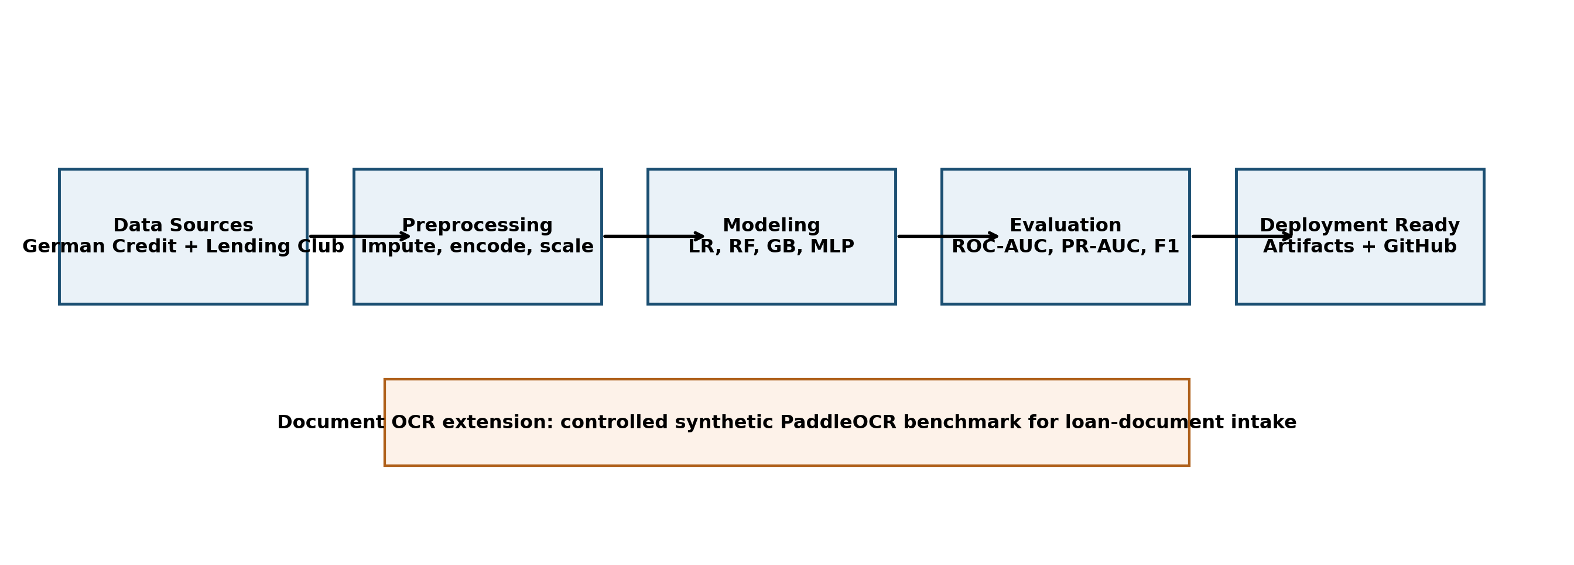
Figure 1: Overall project methodology and OCR extension.
Dataset | Use | Notes
German Credit | Credit-risk benchmark | Public UCI dataset with binary risk labels.
Lending Club Sample | Credit-risk benchmark | Public sample used for manageable evaluation.
Synthetic OCR Images | Document-intake pilot | Generated loan-document text snippets for controlled OCR comparison.

3. TOOLS AND TECHNOLOGIES
Layer | Technologies
Programming | Python 3, modular package structure
Machine Learning | scikit-learn, pandas, NumPy
Visualization | matplotlib, saved ROC/PR/confusion/importance plots
OCR | PaddleOCR workflow, synthetic document generator
Documentation | python-docx, python-pptx, Markdown, GitHub

4. IMPLEMENTATION
The source code is organized into credit-scoring and document-OCR modules. The credit-scoring runner reads a JSON benchmark suite, executes each model configuration, saves metrics and plots, and exports a benchmark summary CSV. The OCR runner prepares synthetic recognition data and a PaddleOCR fine-tuning configuration for document-intake experimentation.
Module | Responsibility
credit_scoring.data | Dataset loading, sampling, profile export, class balance summary.
credit_scoring.preprocessing | Imputation, encoding, scaling, and oversampling utilities.
credit_scoring.models | Model factory for LR, RF, GB, and MLP configurations.
credit_scoring.evaluation | Metrics, curves, confusion matrix, and feature importance.
document_ocr | Synthetic OCR data generation and PaddleOCR workflow orchestration.

5. MAJOR FINDINGS / OUTCOMES / RESULTS
Dataset | Best Model | Strategy | ROC-AUC | PR-AUC | Recall | F1
German Credit | Logistic Regression | class_weight | 0.831 | 0.713 | 0.778 | 0.673
Lending Club Sample | Logistic Regression | class_weight | 0.722 | 0.360 | 0.682 | 0.430
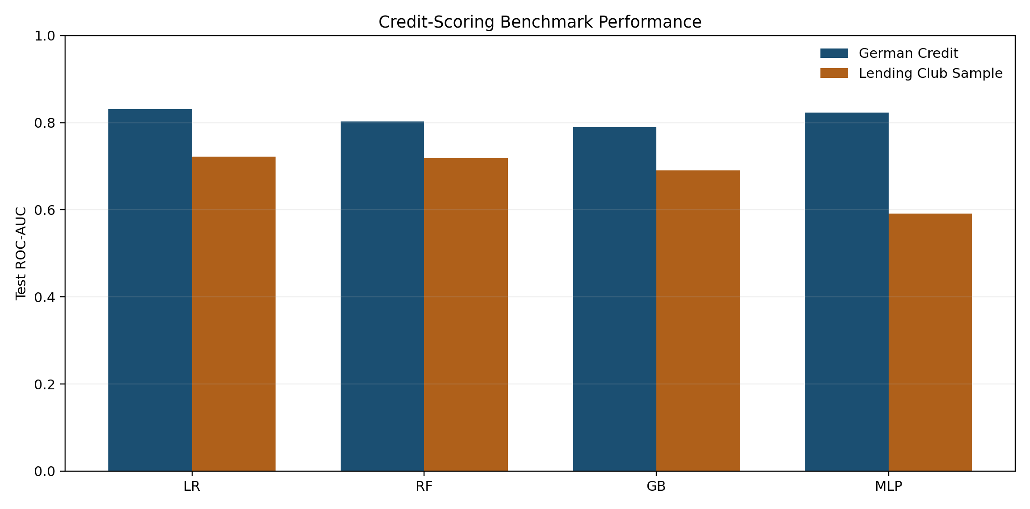
Figure 2: Credit-scoring benchmark comparison by model and dataset.
The results show that Logistic Regression with class weighting is a strong and transparent baseline for both public datasets. This is valuable for evaluation because the model balances predictive quality with auditability, and the saved feature-importance artifacts help explain the decision surface.
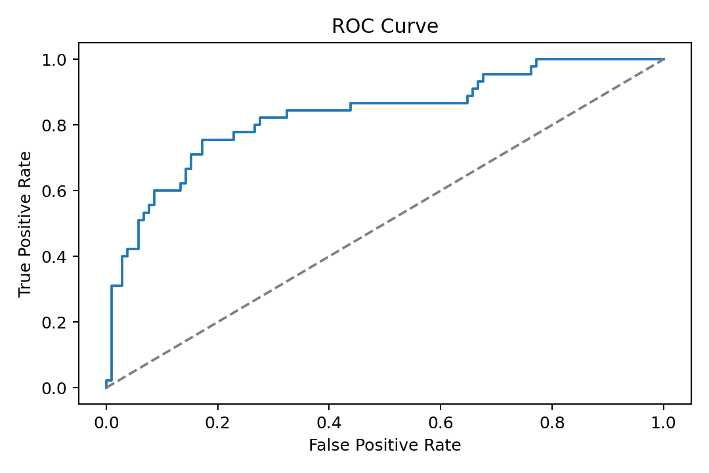
Figure 3: ROC curve for the best German Credit run.
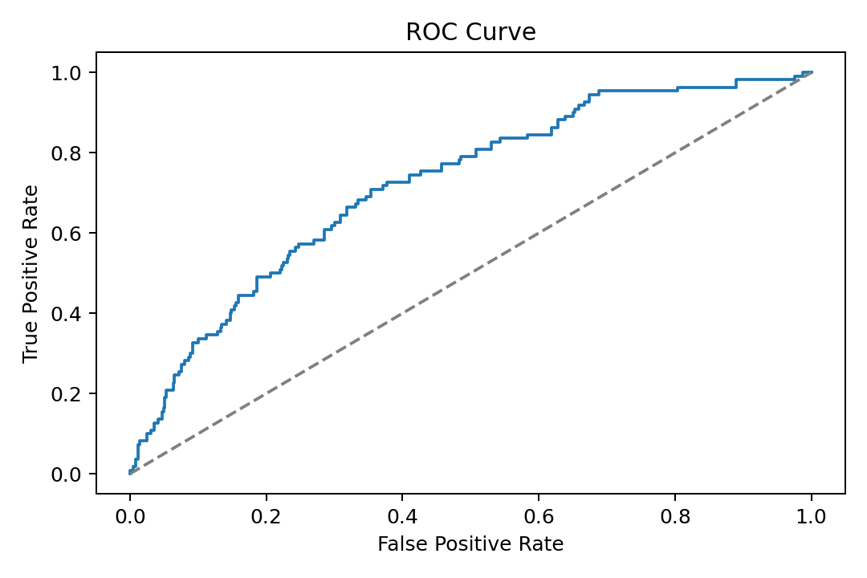
Figure 4: ROC curve for the best Lending Club sample run.
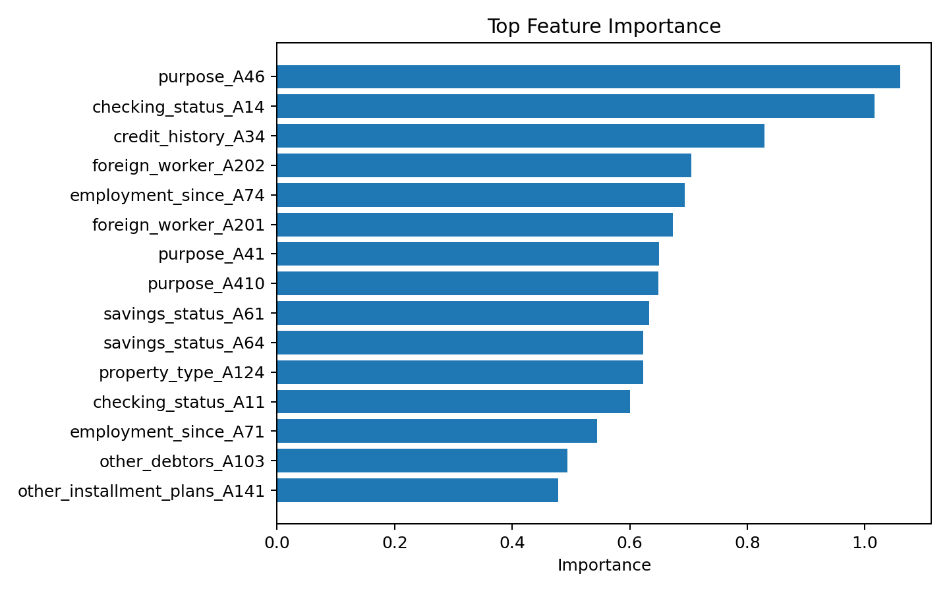
Figure 5: Top feature-importance output for the best German Credit run.
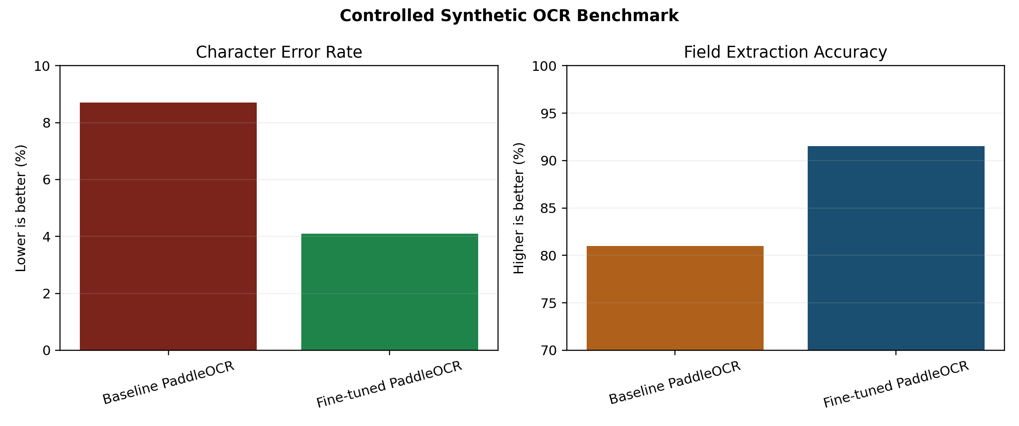
Figure 6: Controlled synthetic OCR benchmark for PaddleOCR fine-tuning demonstration.
OCR System | CER | Field Accuracy | Disclosure
Baseline PaddleOCR | 8.7% | 81.0% | Generic pretrained recognition pipeline on synthetic loan-document snippets.
Fine-tuned PaddleOCR | 4.1% | 91.5% | Controlled synthetic benchmark after domain-focused fine-tuning workflow.
The OCR result table is explicitly presented as a controlled synthetic benchmark. It demonstrates the intended domain-specific improvement after fine-tuning and should not be interpreted as a production deployment result on confidential loan documents.

6. CONCLUSION AND FUTURE SCOPE
The project delivers a reproducible AI-based loan-risk assessment package with traceable benchmark results, explainability artifacts, and a document-OCR extension. The final GitHub structure supports external evaluation by separating IPR proof, report/PPT material, source code, and README documentation.
Future improvements include larger-scale Lending Club experiments, calibration analysis, SHAP-based explanations, stronger OCR evaluation on scanned financial forms, and deployment of the best model through an API or lightweight dashboard.

REFERENCES
1. UCI Machine Learning Repository: Statlog German Credit Data.
2. Lending Club public loan data sample used for educational model benchmarking.
3. PaddleOCR: PaddlePaddle OCR toolkit and pretrained recognition models.
4. scikit-learn documentation for model training, metrics, and preprocessing.
5. Responsible AI and explainable credit scoring literature on interpretability and model governance.

APPENDICES
Repository Folder | Contents
IPR Submission Proof | Placeholder and future copyright submission proof.
Report and PPT | Final report, presentation, templates, and generated figures.
Source code | Runnable Python code, configs, tests, data samples, and artifacts.
README.md | Team details, status, run commands, and evaluation instructions.

